**INTEGRANO Case Study Information Sheet**

|  |  |
| --- | --- |
| **Case Study Number and Title** | **N.2 WATER MEMBRANES** |
| **Case Study Owner** | **Francesca Deganello (CNR-ISMN)** |
| **Partners Involved in the Case Study and Their Role(s):** | **CNR-ISMN**  i) will lead and supervise Case Study N.2  ii) will prepare the thermocatalytic nanopowders CSF-Sil1-Rust and CSF-Sil1-Rice and CSF-Sil1-Rust-Rice (CSF-SIL1X)  iii) will characterize thermocatalytic nanopowders at least by XRD diffraction (with Rietveld analysis), Temperature Programmed Reductions, X-ray Photoelectron Spectroscopy and N2-adsorption.  iv) will characterize bio-SiO2@TiO2 antibacterial nanopowders by TGA and XPS  **CENTI**  i) will supply SiO2-Rice powder extracted from Rice Husks  ii) will prepare bio-SiO2@TiO2 antibacterials nanoparticles from SiO2-Rice  iii) will coat the best antibacterial nanopowder onto SiC flat membranes by spray coating  iv) will coat the best thermocatalytic powder onto SiC scraps by spray coating  **B4C**  i) will supply the SiC scraps and SiC flat membranes  ii) will coat the thermocatalytic nanopowder onto the SiC scraps using dip-coating from combustion sol  iii) will create a TPBR with the coated SiC scraps and will perform the filtration experiment  iv) Morphological analysis (SEM and support for TEM) of nanopowders and coated SiC  v) Support for structural analysis by XRD  vi) Mechanical tests on flat membranes and scraps  **BIU**  i) will deposit the CSF-Sil1X nanoparticles onto SiC scraps using sonochemical coating  ii) will deposit the bio-SiO2@TiO2 nanoparticles onto SiC flat membranes using sonochemical coating  iii) will test the antibacterial properties of the CSF-SIL1X coated SiC scraps and of the bio-SiO2@TiO2 coated SiC flat membranes  iv) TEM and support for SEM  **ISMMC**  i) will test the water coming out of the TPBR reactor for BPA and other contaminants of interest.  ii) will perform leaching experiments on the powders and on the coated nanomaterials |

* **Case study aim, scope and goals. Briefly indicate the synthesis and incorporation plans, the applications of the NMs and NEPs, and define the life cycle stages of the nanomaterial:**
  + **Case study objective:** (why are we addressing this case study? Which is its relevance? For whom/stakeholder?) e.g. development of a new photocatalytic element / component of device/material

This case study is related to the NanoTheC-Aba European project “CECs and AMR bacteria pre-concentration by ultra-nano filtration and Abatement by ThermoCatalytic Nano-powders implementing circular economy solution” financed by Acquatic Pollutants (1 sept 2021-31 Dec 2024).

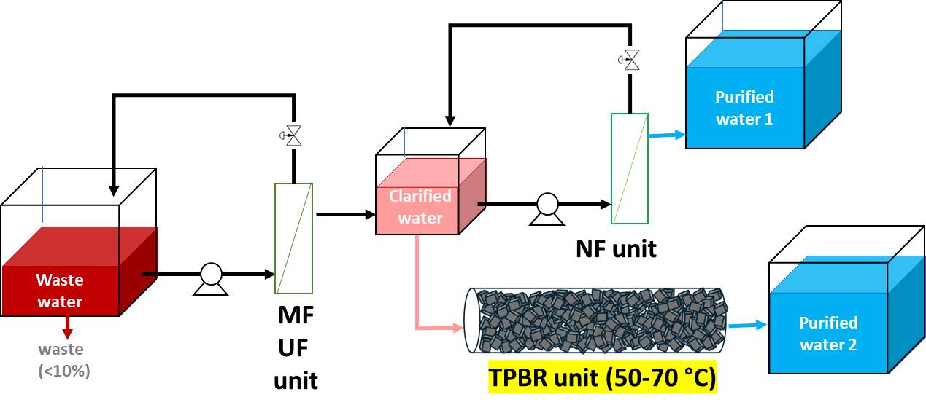

In this project, two of the three units for the water purification have nanomaterials as active phases. MF unit is a Micro Filtration SiC flat membrane coated with nanostructured oxides that have antibacterial functionality, whereas TPBR is a Triple Packed Bed Reactor made of SiC scraps coated with nanostructured oxides with thermocatalytic functionality for the wastewater organic pollutants degradation. The integrated units have already a good level of sustainable materials and processes, ranging from waste and heat recycling to efficient processes, although a step further toward sustainability can be still done. In the INTEGRANO project, we want to take actions to increase the sustainability of these two materials (CS2.1) and of their incorporation process (CS2.2).

* + **Case study strategy:** innovation, substitution, improvement, accomplishment by studying further life cycle stages, data integration of an already investigated case study….

For CS2.1, the strategy is to use waste precursors for the synthesis of the two nanopowders, whose synthesis protocol have been already optimized in the first 2 years of NanoTheC-Aba project. For this purpose, the synthesis (solution combustion synthesis) of new nanopowders from waste precursors will be performed and their functionality will be tested, to select the best waste precursor to be used for the incorporation study (CS2.2).

In particular, Ce-doped SrFeO3-silica (CSF-Sil1) nanopowders will be prepared for the first time i) using Rust waste as iron precursor (CSF-Sil1-Rust), ii) using Silica from rice husk as silica precursor (CSF-Sil1-Rice) and iii) using both rust waste and silica from rice husk as iron and silica precursors (CSF-Sil1-Rust-Rice). Their pchem properties, thermocatalytic functionality and chemical stability in water (leaching) will be tested and only one material will be selected for the incorporation study. At the beginning of the study, their antibacterial properties will be also tested to check if these materials have a double functionality (as suggested by the existing literature papers on doped SrFeO3 compounds).

The other nanomaterial is bio-SiO2@TiO2, that will be prepared for the first time using SiO2 extracted from rice husk (bio-silica) followed by TiO2 hydrothermal coating of the bio-silica powder. The different features of the bio-silica with respect to the silica obtained by hydrothermal synthesis, as in the NanoTheC-Ana Project, will pose some challenges in the TiO2 coating, and this will make necessary to change the original synthesis protocol, by adjusting synthesis parameters like the ratio of titania precursor-to-ethanol to control the titanium oxide thickness, and others. Their pchem properties, antibacterial functionality, and chemical stability in water (leaching) will be tested, and the best SiO2@TiO2 nanomaterials derived from bio-silica will be selected for the next incorporation process.

For CS2.2, the strategy is to try three different incorporation methodologies (Spray coating, Dip coating from combustion sol, sonochemical coating), that have been previously optimized by the CS2 partners for other mixed oxides and select the most sustainable incorporation process. The best nanomaterials obtained in the CS2.1 step will be coated onto SiC scraps by sonochemical coating, dip-coating from combustion sol and spray coating (CSF-Sil1) or onto SiC flat membranes by sonochemical coating and spray coating (bio-SiO2@TiO2). The functionality of the water membranes will be tested to select the best incorporation methodology in terms of thermocatalytic or antibacterial performance, mechanical stability and chemical stability under operation conditions. Filtered water coming from the TPBR unit and from the AM-MF unit will be tested to check the water quality (metal cations leaching, presence of BPA residuals, bacteria). Only one organic pollutant will be selected, that will be probably Bisphenol A (BPA), the most tested organic pollutant during NanoTheC-Aba project.

* + **Life cycle stage to be addressed:** (synthesis, and/or incorporation, and/or use phase and/or end-of-life) Synthesis (CS2.1) and incorporation (CS2.2) life cycle stages
* **Are there pre-existing data available for this case study? E.g.**
  + yes previous life cycle stage(s) data like synthesis (if you are now addressing to the incorporation phase) Yes, all the synthesis and characterization results from the NanoTheC-Aba project are present, although they refer to the old materials prepared from commercial precursors. Therefore, existing data can be useful since they have optimized protocols, that represent the starting point of the new synthesis and incorporation processes, although they might be not very useful other than for comparison with new data. It should be underlined that the utilization of the NanoTheC-Aba previous data for the INTEGRANO project is subjected to authorization by the NanoTheC-Aba partners that do not take part to the INTEGRANO project, ie.: Aalborg University, Denmark and UNITO group of analytical chemistry. Moreover, we have more data on synthesis, structural, surface and redox characterization, and on catalytic activity on some organic pollutants, than data on the incorporation process and test of the final water membranes, although these data will be available during the following months (NanoTheC-Aba proje3ct is still ongoing up to December 2024).
  + yes same life cycle stage, incomplete DoE matrix data
* **List of the (expected/addressed) relevant Key Performance Indicators (KPIs)** **for the case study), which imply experimental characterisation and tests:** 
  + **-**p-chem properties: (such as Z-potential, nanoparticle size;…) Phase composition and crystal mean size (X-Ray Diffraction), surface characterization (X-Ray Photoelectron Spectroscopy), surface area and particle size distribution (N2-Adsorption measurements), redox properties (Temperature Programmed reductions and oxidations), Morphology (Scanning Electron Microscopy and Transmission Electron Microscopy), mechanical characterization of coated scraps and flat SiC membranes (Flexural strengths, compressive strengths, abrasion, scratch).
  + functionality tests: (such as antibacterial or photocatalytic activity) Antibacterial properties of both powders, membrane support and coated membrane (minimum inhibitors concentration, gram + and - , minimum bactericide concentration), thermocatalytic properties of powder and coated scraps (catalytic tests in batch of on the coated SiC scraps at about 70 °C with Bisphenol-A), concentration of the selected organic pollutant in filtered water by HPLC (COD) and leaching Sr, Ce, Fe, Ti, Si by ICP-OES.
  + Human Toxicity tests: which? (e.g. genotox, oxidative stress, ….) which end point? (e.g. skin, lung, intestine,…)
  + Eco-tox tests: which? which addressed environmental compartment/ species? Which end point is addressed? Nanopowders toxicity (ask to other partners in the consortium-for the two best nanomaterials), toxicity of the filtered water due to possible leaching phenomena (see above discussion).
  + Emission sampling campaign: which kind? (e.g. leaching, airborne NP sampling,…) Which environmental compartment? (air, water, soil?) Wastewater
* **List the relevant Key Decision factors (KDFs) (e.g. reagent concentrations, processing parameters, synthesis temperature) for the case study(*):**
  + **Minimum and sufficient number of KDFs:** e.g. 2 KDFs

4 KDFs for CS2.1 and 7 KDF for CS2.2

* + **What KDFs:** (quantity addressed e.g. reagents in a formulation, processing parameters,…etc.)

KDFs in CS2.1

KDF2.1.1 Synthesis of CSF-SIL1: use of different types of waste precursors – waste precursors: silica from rice husk, rust waste or both (discrete variable; 3 waste precursors)

KDF2.1.2 Synthesis of CSF-SIL1: reducers-to-oxidizer ratio (continuous variable; range 1-2) or pH (continuous variable-range 2-7), depending on the initial results

KDF2.1.3 Synthesis of bio-SiO2@TiO2: ratio of titania precursor-to-ethanol to control the titanium oxide thickness (discrete variable)

KDF2.1.4 Synthesis of bio-SiO2@TiO2 from rice husk: temperature (°C)/time (h) of the hydrothermal synthesis to control the crystal size (continuous variable)

KDFs in CS2.2

KDF2.2.1 Dip-Coating of CSF-SIL1: sol concentration (g/L),

KDF2.2.2 Dip-Coating of CSF-SIL1: number of subsequent coatings/coating time (min)

KDF2.2.3 Sonochemical coating of CSF-SIL1: initial concentration of the nanoparticles/reaction time

KDF2.2.4 Spray coating of CSF-SIL1: flow rate/speed belt

KDF2.2.5 Spray coating of CSF-SIL1: nanoparticles concentration in the dispersion (mg/L)

KDF2.2.6 Spray coating of bio-SiO2@TiO2: preliminary tests to select the KDFs among flow rate (ml/min) or speed belt (m/min) (continuous variable) and nanoparticle concentration

KDF2.2.7 Sonochemical coating of bio-SiO2@TiO2: initial concentration of the nanoparticles/reaction time)

* + **KDF is it a discrete or continuous variable?** (level / continuous e.g. number of nozzles in spray coating is discrete variable, flow rate is continuous variable)

See above

**Unit of measurement of the KDF:** e.g. flow rate ml/min…. See above

**(for continuous) KDF values range:** eg. KDF1 0.5ml/min<flow rate<2.7ml/min, …. See above

**(for discrete) KDF levels:** e.g. low, medium, high See above

(*) please note that:

* the KDF selection is primarily addressed to the targeted functionality level of the solutions (e.g. Nano material functionality, product functionality,….)
* KDFs may be selected based on process experience / use phase or end-of life options analysis ….
* KDF number is strongly affecting the number of experiments: e.g.
  + # **2** KDFs imply a minimum number of **6** measured samples with average value and uncertainty
  + #**3** KDFs imply a minimum number of **10** measured samples with average value and uncertainty
  + **….**
* KDF selection may be based on:
  + Process experts
  + Available previous (primary=specific and owned) data on process and its effects on experiment results
  + Available data from the literature, databases,….